We first create a directory in desktop



Then get inside the directory and summon a file called slowris from github



Then update the directory



Then install apache

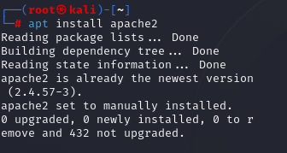

Then run the code to start it



Then this code to check if the system is active or not

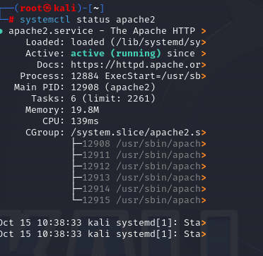

Then check the IP address

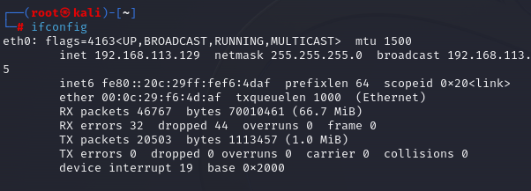

Run the ip check of the site is there

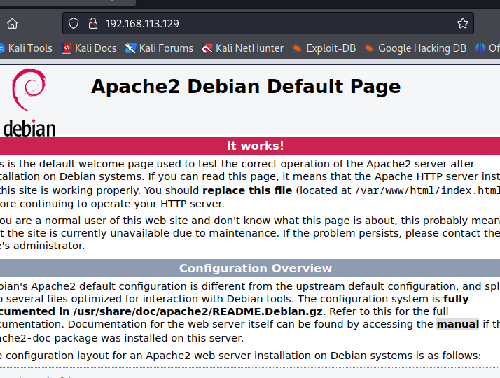

Then go to the slowloris file

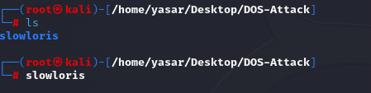

And run the code for the attack

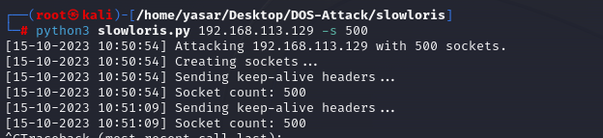

Check if the site is coming on

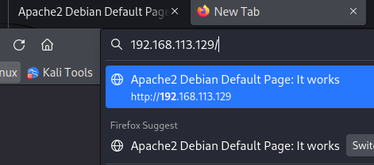

Then stop the attack and check



Then end the apache service

